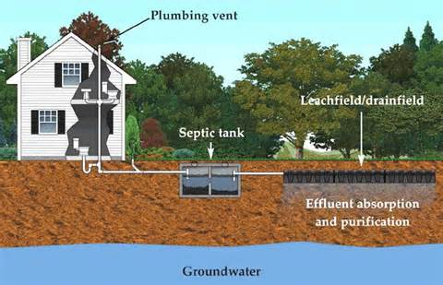
GET TO KNOW YOUR
SEPTIC SYSTEM
Many communities in Owen County, including (your community) depend on residential Septic Systems to treat and dispose of household wastewater from bathrooms, kitchens, and laundry. Septic systems can be a cost effective and efficient method of wastewater treatment when properly designed, installed, and maintained. By using natural processes to treat the wastewater onsite, usually in a homeowner’s backyard, septic systems don’t require the installation of miles of sewer line connected to a distant treatment plant. On the other hand, septic system maintenance is the responsibility of the home owner and requires regular inspection and pumping to avoid system failure. A failing system can result in health and environmental threats to families and communities.

Some local residents have grown up in a home with a septic system and know the “Do’s and Don’t’s” of what can be flushed or disposed of down the drain and associated system maintenance responsibilities. Others have moved from an area served by a piped sanitary sewer system and may not even be aware that they have a septic system.

The information in this packet provides homeowner tips for proper usage and maintenance of a residential system. The Septic System Checklist can help keep you on a maintenance schedule. In case you’re not sure, the enclosed video helps answer the question “Do I have a Septic System and How Do I Find It?” Also enclosed are links to local authorities, licensed pumping contractors, and more information on different types of systems and where they are best utilized. You can help get the word out.

Share this information with your friends and neighbors, distribute to your neighborhood association or block club.

Consider joining with communities across Owen County to promote Septic System Awareness Week scheduled for September 22, 2014 and sponsored through the EPA SepticSmart Program. For more information or to get involved locally in Septic System Awareness Week, contact (your contact information).

